Phase 2 - Fundamentals of Natural Language Processing
Natural Language Processing

Ramos Ruiz, Jerónimo

Abstract

Introduction
This report uses the CISI corpus (“CISI: a dataset for Information Retrieval”), a public benchmark collection from the University of Glasgow’s Information Retrieval Group to apply lexical resources and text corpora for text analysis and develop structured Python programs to extract relevant information from plain text and categorize it using NLP techniques. The dataset is freely available on Kaggle and contains 1,460 documents (mainly scientific and technical abstracts in library and information science), 112 queries and relevance assessments that map each query to its relevant documents.
The code was developed in a Jupyter Notebook running in Visual Studio Code using a Google Colab kernel. This approach was chosen to maintain the project's full structure and to work with a version control system like GitHub (the link to the repository is provided at the end of this report).
We used libraries for NLP such as: nltk (used for tokenization, stopwords, stemming, lemmatization, POS tagging), contractions (expands informal contractions ("don't" → "do not") as part of slang/jargon normalization), unicodedata (strips diacritics/accents), re (regex-based noise removal). And for the machine learning models, as well as to measure their effectiveness, we use the sklearn and gensim libraries.
Methodology
The original dataset comes from the Centre for Inventions and Scientific Information (CISI). It was compiled, formatted, and distributed according to standard procedures by the University of Glasgow's Information Retrieval Group for the evaluation of search systems.
The corpus is divided into three main types of interrelated elements: documents (1,460 scientific texts), queries (112 user information requests), and relevance judgments (3,114 annotated "query-document" relationship pairs determining which text answers which question).
The collection is stored in plain-text files structured using metadata tags. Document attributes and queries consist primarily of unstructured text (alphanumeric) and numeric keys (identifiers):
Table 1. Database architecture used for analysis
Document | Attribute | Data type | Description
Documents (CISI.ALL) | ID (.I) | Integer | Unique document identifier (1 to 1460).
Documents (CISI.ALL) | Title (.T) | Text | Title of the publication or scientific article.
Documents (CISI.ALL) | Author (.A) | Text | Name(s) of the document's author(s).
Documents (CISI.ALL) | Abstract (.W) | Text | Summary of the content or body of the text.
Documents (CISI.ALL) | Cross-references (.X) | List | Identifiers of other cited documents.
Queries (CISI.QRY) | ID (.I) | Integer | Unique query identifier (1 to 112).
Queries (CISI.QRY) | Query Text (.W) | Text | Text written by the user describing their need for information.
Relevance Judgments  (CISI.REL) | Query ID | Integer | Query ID
Relevance Judgments  (CISI.REL) | Document ID | Integer | ID of the document relevant to that query.

Now, knowing the structure of the data we will be working with, we applied a preprocessing process that consisted of:
- Expanding contractions, slang and abbreviation normalization (text level, pre-tokenization): Two complementary techniques were used here: 1. Contraction expansion (`don't` → `do not`, `it's` → `it is`) via the `contractions` library — this is standard informal – language normalization. 2. Domain/abbreviation dictionary lookup — a small, extensible mapping of common abbreviations, internet slang, and library/information-science shorthand (`govt.` → `government`, `dept.` → `department`, `approx.` → `approximately`, `u` → `you`, etc.).

- Case normalization: We converted all text to lowercase so that, e.g., `"Library"`, `"library"`, and `"LIBRARY"` were treated as the same token. This is done early, since several later steps (stopword lists, abbreviation dictionary lookups) are easier to match in a single case.

- Noise removal at text level (URLs, emails, HTML): We stripped content that carries little to no informational value for downstream text analysis or retrieval: URLs, email addresses, HTML/markup fragments.

- Diacritics removal: We remove accented characters (e.g. `é`, `ï`, `ñ`), so the text can be normalized to their closest plain-ASCII form using Unicode's NFKD decomposition, which separates a base letter from its combining accent mark, and then discarding the combining marks. This ensures `"café"` and `"cafe"` are treated as the same token.

- Tokenization: In this step we divided the cleaned text into individual word tokens, using NLTK's `word_tokenize`: a Penn-Treebank-style tokenizer that correctly separates punctuation from words and handles common English tokenization edge cases).

- Noise removal at token level (punctuation, numbers, very short tokens). In this case we removed punctuation, standalone numbers, and leftover extra whitespace. Very short leftover tokens (length ≤ 1) are also dropped, as they are almost always artifacts of punctuation stripping rather than real words.

- Abbreviation/slang normalization (token level). The same process as step (1) but at token level.

- Stopword removal: We removed high-frequency, low-information function words (`the`, `of`, `and`, ...) using NLTK's built-in English stopword list. This was applied after noise removal and tokenization so that punctuation attached to a stopword doesn't prevent a match.

- Stemming and Lemmatization.
  - Stemming: It’s the process focused on reduce each word to a crude root form by chopping off common suffixes, using the Porter Stemmer — the classic, fast stemming algorithm for English. Stemming is aggressive and can produce non-dictionary forms (e.g. `"classification"` → `"classif"`), but it is very effective at conflating word variants for retrieval/indexing tasks.
  - Lemmatization: In this process we reduce each word to its dictionary base form (lemma) using WordNet's `WordNetLemmatizer`. Unlike stemming, lemmatization uses vocabulary and morphological analysis to return real words (e.g. `"classification"` stays `"classification"`, but `"editions"` → `"edition"`, `"published"` → `"publish"`). Accuracy is greatly improved by first tagging each token with its part of speech (noun/verb/adjective/adverb) using NLTK's POS tagger and passing that into the lemmatizer, since the same surface form can lemmatize differently depending on its role (e.g. `"studies"` as a noun → `"study"`, as a verb → `"study"`, but `"better"` as an adjective stays `"better"` while as an adverb → `"well"`).
This process was applied over every document's abstract (`.W` field) and the results were stored in one dataframe that contains the tokenized, stemmed, and lemmatized forms alongside the original text.
It is important to note that we will not use the cross-reference block, as it is not part of the document text and cannot be used to obtain relevant information.
Now, with a clean and normalized sequence of tokens available, we transform these tokens into numerical vectors that a model can process. We implement and compare five representations, progressing from simple or sparse ones to distributed or dense ones:
- Sparse and count-based: in these representations, each document constitutes a row and each unique term or n-gram a column.
  - Bag of Words (BoW): BoW represents each document as a vector of raw (or binary) term counts over the corpus vocabulary, completely ignoring word order. We use scikit-learn's `CountVectorizer`, which also lets us cap the vocabulary (`min_df`/`max_df`) to control sparsity, in this case we require a term to appear in at least 2 documents, to drop one-off noise that survived cleaning.
  - Bigrams (n-grams): Pure BoW treats "information retrieval" as two independent, unordered terms — indistinguishable from a document that separately mentions "information" and "retrieval" in unrelated contexts. Bigrams (2-grams) instead capture adjacent word pairs, recovering some local word order and multi-word domain terms (e.g. "decimal classification", "information retrieval", "technical librarie") that are highly meaningful in a library/IR corpus but invisible to unigram BoW.
  - TF-IDF: TF-IDF re-weights raw counts by how distinctive a term is across the corpus: term frequency (how often a word appears in a document) is multiplied by inverse document frequency (a down weighting factor for words that appear in many documents and are therefore less discriminative). Each document remains the unit of analysis (one row per document), but the resulting vectors emphasize the words that best characterize that specific document rather than words that are merely frequent corpus-wide (e.g. `system`, `information` in this corpus).

- Dense and distributed: here, each word is represented by a low-dimensional dense vector that captures semantic similarity, and document vectors are subsequently obtained by aggregating (averaging) the word vectors.
  - Word2Vec: Word2Vec learns a dense vector for every word by training a shallow neural network to predict a word from its context (CBOW) or the context from a word (Skip-gram), so that words appearing in similar contexts end up with similar vectors. We train Word2Vec from scratch on the CISI corpus itself using `gensim`, since Word2Vec's whole premise is learning embeddings from a corpus's own distributional statistics.
To use Word2Vec at the document level (needed for a fair comparison with BoW/TF-IDF, which are document vectors), we pool each document's word vectors by simple averaging — a standard, simple baseline for turning word embeddings into document embeddings.
  - GloVe: Unlike Word2Vec's local context-window prediction objective, GloVe (Global Vectors) learns word vectors from global word-word co-occurrence statistics aggregated over an entire corpus.
Because GloVe needs a very large corpus to produce good vectors, and CISI is far too small to train GloVe from scratch, we instead load a pretrained GloVe model (trained on Wikipedia + Gigaword, 50-dimensional) via `gensim`'s model downloader and apply it to our (already cleaned/lemmatized) CISI vocabulary.
It is worth noting that all text representations and models will be constructed from the stream of lemmatized tokens, given that lemmas preserve the actual dictionary words, making GloVe far more effective than if morphological roots (stems) were used.
Also, to make the comparison of text representations concrete rather than purely statistical, we picked one CISI document as a "query" and retrieve its most similar documents under TF-IDF, Word2Vec (corpus-trained), and GloVe (pretrained), all three using cosine similarity.
Now, to train the models and bearing in mind that CISI is an ad-hoc retrieval test collection, it does not have a labeled classification dataset. Rather than inventing an arbitrary label (e.g. from clustering the very features we're about to classify on, which would be circular), we will build a binary label from `CISI.REL`, the collection's real relevance judgments. The labels will be assigned as follows: Label = 1: if a document was judged relevant to a specific query. Label = 0 otherwise.
We did this by taking advantage of the fact that `CISI.REL` contains 3,114 queries. –document relevance pairs covering 76 of CISI's 112 queries. As a case study we picked query #44 which states the following: "There are presently fifty to one hundred technical journals being published... What attempts have been made to cope with this amount of scientific and technical publication in terms of analysis, control, storage, and retrieval?" because it has the most judged-relevant documents (155 of 1,460, ≈10.6%), giving the largest, most learnable positive class while still being a realistically imbalanced classification problem, exactly the kind of scenario a text-classification pipeline needs to handle robustly in practice.
The split is stratified on the label so both the training and test sets preserve the same ~10.6% positive rate as the full corpus. As a result, we used 80% (1168 documents) of the corpus to train the models and 20% (292 documents) to test its behavior.
With only ~10.6% positive examples, a naive classifier can score ~89% "accuracy" just by predicting "not relevant" every time — while being completely useless. We address this with random oversampling of the minority class, applied inside an `imblearn` pipeline together with each classifier.
This placement matters: oversampling must happen only on each cross-validation fold's training partition, never on the validation or test partition. Oversampling globally before cross-validation lets duplicated copies of the same original minority-class documents land in both the training and validation folds simultaneously, which leaks information across the split and produces overly optimistic (and unreliable) cross-validation scores. Wrapping the sampler and the classifier in one pipeline that `GridSearchCV` treats as a single unit avoids this leak automatically.
Each model is grid-searched over a small, targeted hyperparameter grid 3-fold stratified CV and scored on F1. We used the F1 score because accuracy alone would reward always predicting the majority class). Grids are kept modest to keep total runtime reasonable; each is still large enough to materially change results.
We trained the following models:
- Logistic Regression: Known to have a linear baseline: fast, interpretable (coefficients map directly to TF-IDF terms), and a strong baseline for high-dimensional sparse text features.
- Naïve Bayes: `MultinomialNB` is the classical choice for count/TF-IDF text features — it assumes conditional term independence given the class, which is unrealistic but works surprisingly well in practice and trains almost instantly.
- k-Nearest Neighbors: It’s a non-parametric baseline as it classifies a document by the majority label among its k nearest neighbors in TF-IDF space (cosine-like distance implicitly, since TF-IDF vectors are L2-normalized). No training phase, but prediction requires scanning the training set.
- Decision Tree: A single interpretable tree over TF-IDF features (splits on "does term X exceed threshold Y"). Prone to overfitting on high-dimensional sparse text data, which is exactly why ensembles of trees (Random Forest, Gradient Boosting, below) tend to outperform a single tree.
- Support Vector Machine: SVMs are a classical strong performer for high-dimensional sparse text classification (TF-IDF vectors are exactly the setting SVMs were originally popularized for in text categorization). We compare a linear kernel (appropriate when classes are close to linearly separable in the original TF-IDF space — often true for text) against an RBF kernel.
- Random Forest: A bagging ensemble of decision trees. For this model we compared Random Forest's default `max_features='sqrt'`, which collapsed the model to predicting the majority class only — with 3,672 sparse TF-IDF features, considering only √3672 ≈ 60 random features per split made it very unlikely any single split would land on a feature useful for the rare positive class. In this sense, we also used the `max_features=None` (consider all features at each split).
- Gradient Boosting (boosting ensemble): In this case the trees are added sequentially each one fit to correct the residual errors of the ensemble so far, which — unlike bagging — makes boosting inherently more sensitive to (and, when tuned well, more effective at) hard, rare examples such as our minority class.
- Neural Network (MLP): we use a shallow multilayer perceptron (`MLPClassifier`) rather than a deep architecture, for reasons specific to this dataset:
- Corpus size: With only 1,460 documents (1,168 in the training split), a deep network has far more parameters than the data can meaningfully constrain — a recipe for overfitting, not better performance.
- Input representation: TF-IDF vectors are already a strong, hand-engineered representation (unlike raw pixels/audio, where deep nets earn their keep by learning representations from scratch); a shallow net is a natural match.
- Search grid: one or two hidden layers (`(64,)` vs. `(128, 64)`) with ReLU activation (`MLPClassifier`'s default) and the Adam optimizer (fast, robust default for this input size), with L2 regularization strength (`alpha`) tuned to control overfitting, and `early_stopping` enabled to halt training once validation performance plateaus — an additional overfitting safeguard appropriate for this small a dataset.
Each model was evaluated using the following metrics: accuracy, precision, recall, and F1-score. We ranked them based on the F1-score, as it is the most informative single metric given the class imbalance present in the available data.
We did not use regression metrics, as this is a binary classification task (relevant vs. non-relevant) rather than a regression task; since there is no continuous target variable to predict, metrics such as R², MSE, and others specific to regression are not applicable and have been deliberately omitted.
As Accuracy, precision, recall, and F1 are all computed at a single decision threshold (0.5 by default). We computed and plotted the ROC and Precision–Recall (PR) curves that show how each model performs across every possible threshold, which is especially informative here: depending on the downstream use case, we might want to move the threshold to trade precision for recall (e.g. a librarian doing relevance screening may prefer to catch more true positives at the cost of a few more false alarms). In this case:
- ROC curve plots the True Positive Rate against the False Positive Rate.
- And ROC-AUC is the probability that a random positive example is ranked above a random negative example — 0.5 is random guessing, 1.0 is perfect ranking.
- PR curve plots Precision against Recall directly.
- And PR-AUC is generally the more informative curve on imbalanced data like ours (~10.6% positive): the False Positive Rate used by ROC has ~1,300 true negatives in its denominator on our test set, so even a fairly large number of false positives barely moves it — ROC-AUC however can look deceptively good on rare-class problems. PR-AUC has no such denominator effect, since both precision and recall are computed only over the (rare) predicted-/actual-positive documents.

Results
Before examining the model results, we will present a comparative analysis of each preprocessing and representation technique applied.

Table 2. Summary and analysis of preprocessing techniques
Preprocessing Technique | Advantages | Limitations
Tokenization | Necessary first step for every downstream technique; NLTK's tokenizer correctly separates punctuation from words, handling contractions/hyphens more reliably than naive str.split() | A single tokenization scheme cannot be optimal for every downstream need; it may still need to be re-split for subwords in transformer-era models
Stopword removal | Sharply reduces token count and noise; lets frequency-based methods such as BoW/TF-IDF focus on content-bearing words | A fixed generic list can remove domain-relevant words; can also hurt phrase-level semantics for n-gram models
Case normalization | Simple, fast, and essential for consistent matching (Library = library); required by nearly every other technique | Loses information distinguishing proper nouns from common nouns and can conflate acronyms with regular words (US vs. us)
Jargon / slang / abbreviation normalization + diacritics removal | Conflates variant surface forms (govt./government, café/cafe) into a canonical token, reducing vocabulary fragmentation | A hand-built abbreviation dictionary is inherently incomplete and domain-specific; contraction expansion can slightly change part-of-speech distribution
Noise removal (URLs, emails, HTML, punctuation, numbers) | Removes tokens with little/no topical signal for retrieval or topic-level tasks; shrinks vocabulary and matrix size | Aggressive number removal can discard informative numeric content such as edition numbers, years, formulas, or standard identifiers
Stemming (Porter) | Fast, rule-based, requires no external resources; aggressively conflates inflectional/derivational variants and substantially reduces vocabulary | Produces non-words (classification → classif); can hurt readability and conflate unrelated words through over-stemming
Lemmatization (WordNet, POS-aware) | Produces real dictionary words while conflating inflectional variants; POS-awareness resolves some ambiguities that stemming cannot | Slower than stemming; requires POS tagging; depends on WordNet coverage, so domain-specific terms and proper nouns may be handled less reliably

Table 3. Summary and analysis of text representation techniques
Text Representation Technique | Advantages | Limitations
Bag of Words (BoW) | Simple, fast, and highly interpretable; every dimension corresponds to a literal word; useful as a baseline for classic IR/classification | Ignores word order and syntax; high-dimensional and very sparse (>99% sparsity); cannot capture semantic similarity between different words
Bigrams (n-grams) | Recovers local word order and phrases lost by unigram BoW; captures meaningful domain collocations such as information retrieval and decimal classification | Feature space grows rapidly with n; sparsity worsens because most groups occur only once; increases model complexity and overfitting risk on small corpora
TF-IDF | Automatically down-weights corpus-common, low-information words; generally, a stronger baseline than raw BoW for retrieval/similarity; document remains the natural unit of analysis | Still ignores word order and semantics; remains high-dimensional/sparse; weights are corpus-relative and therefore not directly comparable across different corpora or over time
Word2Vec | Captures semantic similarity between different words through dense, low-dimensional vectors; supports vector arithmetic and downstream neural methods; can be trained on domain-specific corpora | Requires a large training corpus for good quality; a model trained from scratch on a small corpus such as CISI produces noisier neighbors; document-level representation requires an additional pooling step
GloVe | Captures global co-occurrence statistics and often produces coherent semantic neighbors; pretrained models overcome the small-corpus problem; provides a simple vector lookup interface | Pretrained vectors reflect their original training corpus rather than CISI's library-science domain; some CISI-specific terms may be missing or poorly represented; difficult to fine-tune effectively on a small corpus

As we said before, to make the comparison concrete rather than purely statistical, we picked one CISI document as a "query" and retrieve its most similar documents under TF-IDF, Word2Vec (corpus-trained), and GloVe (pretrained), all three using cosine similarity. This surfaces, very directly, how representation choice changes what "similar" even means.
In this case, we look out for texts related to the title: “Abstracting Concepts and Methods”. And obtained the following results:

Table 4. Results of the query based on the titles with the highest similarity.
Text Representation Technique | Title | Measured similarity
TF-IDF | #571: Automatic Abstracting and Indexing.. II. Production of Indicative Abst | 0.346
TF-IDF | #657: Standards For Writing Abstracts | 0.321
TF-IDF | #1281: Relative Effectiveness of Document Titles and Abstracts for Determinin | 0.270
Word2Vec (corpus-trained, averaged) | #174: Automated Language Processing | 0.920
Word2Vec (corpus-trained, averaged) | #156: Letter to the Editor: Assessment of Information Services | 0.917
Word2Vec (corpus-trained, averaged) | #1248: Reader in Library Service and the Computer | 0.912
GloVe (pretrained, averaged) | #1405: Techniques of Information Retrieval | 0.987
GloVe (pretrained, averaged) | #408: Handbook of Data Processing for Libraries | 0.984
GloVe (pretrained, averaged) | #946: Library Materials | 0.984

It is worth noting that neighbors identified via TF-IDF tend to share exact vocabulary with the query (which is unsurprising, given that TF-IDF similarity is literally a weighted overlap of words). In principle, dense vector representations (embeddings) allow for the retrieval of thematically related documents without the need to share many exact words. However, in this small corpus, it is observed that neighbors obtained using Word2Vec trained from scratch are noisier or less intuitive than those obtained using pre-trained GloVe.
Now we present the hyperparameters used on each model after tunning:

Table 5. Hyperparameters used for each model
Model | Optimal Hyperparameters | Obtained scores
Logistic Regression | C = 10 | accuracy=0.890  precision=0.474  recall=0.290  f1=0.360
Naïve Bayes | alpha = 1.0 | accuracy=0.812  precision=0.260  recall=0.419  f1=0.321
k-Nearest Neighbors | n_neighbors = 9 | accuracy=0.729  precision=0.214  recall=0.581  f1=0.31
Decision Tree | max_depth = 5 | accuracy=0.829  precision=0.298  recall=0.452  f1=0.359
Support Vector Machine (SMV) | C = 0.1  Kernel = ‘linear’ | accuracy=0.870  precision=0.379  recall=0.355  f1=0.367
Random Forest | max_depth = None  max_features = None  n_estimators = 200 | accuracy=0.866  precision=0.346  recall=0.290  f1=0.316
Gradient Boosting (boosting ensemble) | learning_rate = 0.05  n_estimators = 100 | accuracy=0.860  precision=0.344  recall=0.355  f1=0.349
Neural Network (MLP) | Alpha = 0.001  hidden_layer_sizes = (64,) | accuracy=0.866  precision=0.278  recall=0.161  f1=0.204

For each model, we present the confusion matrix (counts of true/false positives/negatives on the held-out test set) and the full per-class classification report (precision, recall, F1-score, and support for both classes):

Table 8. Confusion Matrix for each model
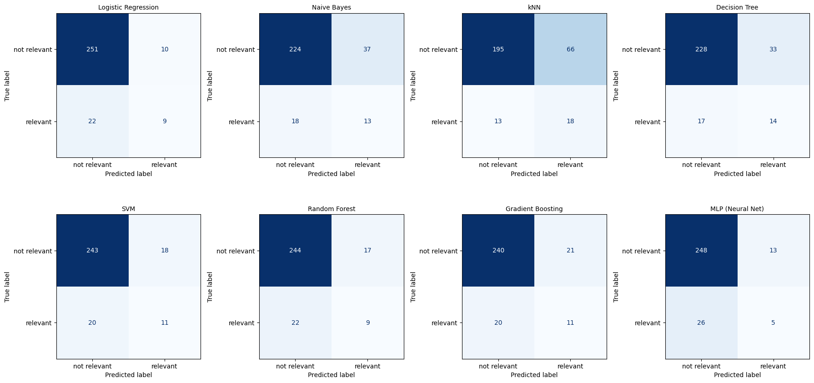

Table 6. F1-scores obtained for each model
Model | F1-score
Model | not relevant | relevant
Logistic Regression | 0.94 | 0.36
Naive Bayes | 0.89 | 0.32
kNN | 0.83 | 0.31
Decision Tree | 0.90 | 0.36
SVM | 0.93 | 0.37
Random Forest | 0.93 | 0.32
Gradient Boosting | 0.92 | 0.35
MLP | 0.93 | 0.20

In this case, it is particularly important not to interpret accuracy as the primary metric, since the test set is imbalanced: there are 261 non-relevant documents (89.4%) and only 31 relevant ones (10.6%).
Now, we can see that the eight models find it much more difficult to identify the relevant class than the non-relevant one. This indicates that the problem is not simply "which algorithm offers the best performance," but rather a matter of discrimination against the minority class.
However, if the model's objective was to find relevant documents, the recall of the relevant class becomes particularly important. Where we have that:

Table 7. Recall and precision obtained for each model trained
Model | Recall |  | Precision
Model | not relevant | relevant | not relevant | relevant
Logistic Regression | 0.96 | 0.29 | 0.92 | 0.47
Naive Bayes | 0.86 | 0.42 | 0.93 | 0.26
kNN | 0.75 | 0.58 | 0.94 | 0.21
Decision Tree | 0.87 | 0.45 | 0.93 | 0.30
SVM | 0.93 | 0.35 | 0.92 | 0.38
Random Forest | 0.93 | 0.29 | 0.92 | 0.35
Gradient Boosting | 0.92 | 0.35 | 0.92 | 0.34
MLP | 0.95 | 0.16 | 0.91 | 0.28

This means that the kNN model identified approximately 58% of the truly relevant documents, which represents, within a test dataset of 31 documents, approximately 18 relevant documents were detected, leaving around 13 undetected. On the other hand, the MLP identified only approximately 16%, which indicates that it was only able to identify 5 relevant documents.

Table 9. Model comparison according to the general metrics obtained on the test set
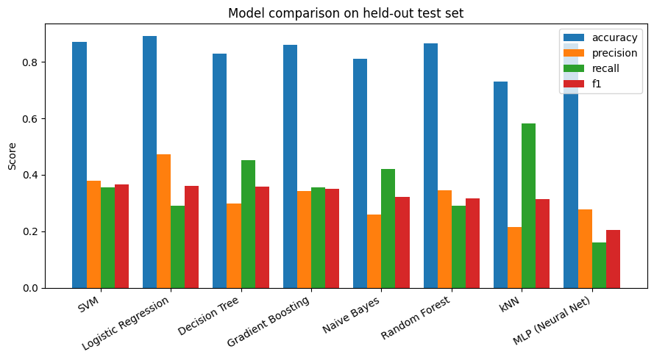

We compute both curves from each model's underlying score:

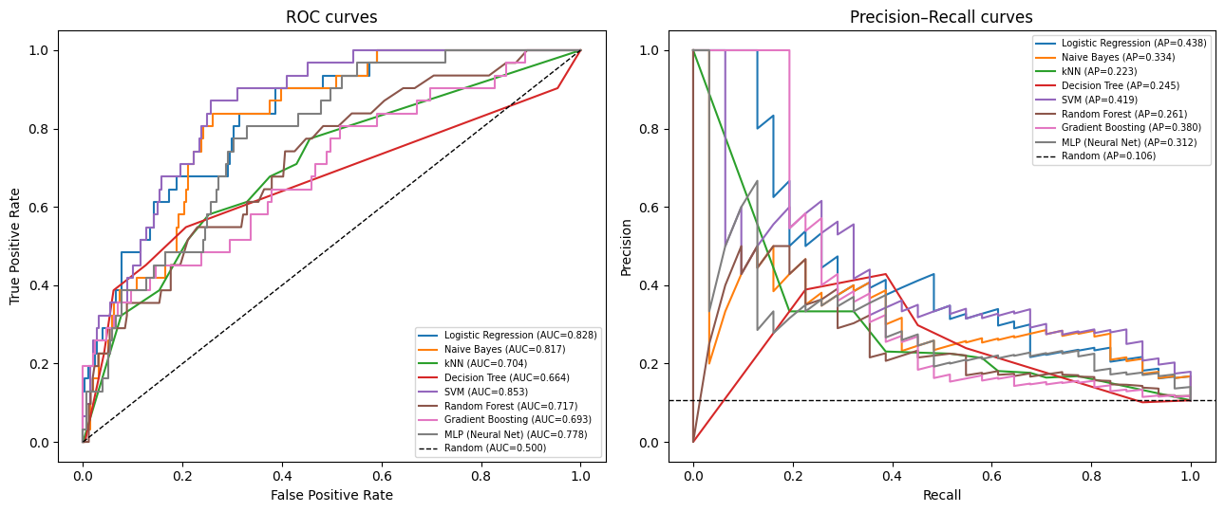

Model | ROC – AUC | PR – AUC
Logistic Regression | 0.83 | 0.44
SVM | 0.85 | 0.42
Gradient Boosting | 0.69 | 0.38
Naive Bayes | 0.82 | 0.33
MLP (Neural Net) | 0.78 | 0.31
Random Forest | 0.72 | 0.26
Decision Tree | 0.66 | 0.24
kNN | 0.70 | 0.22

We can reassure that the linear models lead the system: both Logistic Regression (PR-AUC: 0.44) and SVM (ROC-AUC: 0.85) significantly outperform more complex options such as Neural Networks (MLP) or decision trees.
Also, we can see that there is an imbalance challenge (PR-AUC vs. ROC-AUC). There is a widespread drop in PR-AUC values compared to ROC-AUC across all models. This indicates that the CISI dataset exhibits a significant class imbalance (few positive instances versus many negative ones). While ROC-AUC can be overly optimistic, PR-AUC reveals the models' actual difficulty in correctly identifying and classifying relevant texts (Precision and Recall).
Also, there is a poor performance of tree-based and proximity-based models. Models such as Decision Trees (0.24) and kNN (0.22) rank lowest in terms of PR-AUC. Individual trees tend to overfit on text data, while kNN suffers significantly from the "curse of dimensionality" characteristic of word vector data.

Discussion and conclusions
The results shown on Table 4 surfaces how text representation choice changes what "similar" even means.
Sparse representations (BoW, bigrams, TF-IDF) are simple, fast, fully interpretable, and well-suited to a corpus of CISI's size — they remain strong, low-effort baselines for classic IR tasks. Dense representations (Word2Vec, GloVe) add the ability to capture semantic similarity between different words, which sparse methods fundamentally cannot, but that benefit is conditional on either a large training corpus or a good pretrained model — a small corpus like CISI is exactly the case where training your own dense embeddings is risky, and borrowing pretrained ones (GloVe) is the more reliable choice.
As for the results of the metrics obtained for each model, we can see that:
- According to the Best F1-score: the linear models (SVM with a linear kernel, Logistic Regression) and the shallow Decision Tree were competitive top performers on this task — consistent with the well-known result that linear models are strong, hard-to-beat baselines for high-dimensional sparse TF-IDF text features, and that tree ensembles need a genuinely informative feature interaction structure to outperform them, which a single relevance-judgment-based label may not provide much of.
- According to Precision/recall trade-off: models varied substantially in how they achieved their scores. The kNN and Decision Tree models leaned toward higher recall (catching more true positives at the cost of more false positives), while Logistic Regression and the Neural Net leaned toward higher precision (fewer false alarms but missing more true positives). Which trade-off is "better" depends on the downstream use case (e.g. a librarian screening documents for relevance would likely prefer higher recall, to avoid missing genuinely relevant material).
In general, we saw that class imbalance was the dominant challenge, not algorithm choice per se: naive application of several algorithms (Random Forest with default settings, Naïve Bayes and the Neural Net before oversampling was correctly implemented) collapsed to predicting the majority class only, producing precision/recall/F1 all equal to zero for the positive class despite ~89% "accuracy" — a direct, hands-on illustration of why accuracy alone is a misleading metric on imbalanced data, and why this notebook reports precision/recall/F1 and the confusion matrix for every model rather than accuracy alone.
As a matter of fact, because the label reflects relevance to a *single* query, results here characterize that specific relevance signal rather than any general "document topic" — they should not be over-generalized to other queries or to CISI without re-running the same pipeline against a different (or aggregated) relevance target.

